Project Title: Catering Reservation and Ordering System

By [Aaryan Keer]

Table of Contents :
1 Introduction
- Overview of the Project
- Objectives and Goals
2 System Architecture
- Architecture Diagram
- Explanation of the Architecture
3 Solution Design
- Low-Level Design
  - Component Diagrams
  - Data Models
  - API Details
  - UI/UX Designs
  - Detailed Design
- Security and Permissions
  - Authentication and Authorization Mechanisms
  - Firestore Security Rules
4 Testing Strategy
- Unit Testing
- Integration Testing
- End-to-End Testing
5 Deployment
- Deployment Steps and Environment
6 Conclusion
- Future Work and Enhancements

7 Appendices and Code Listings
- Code Listings
- Outputs
Introduction
Overview of the Project
The Catering Reservation and Ordering System is a web-based platform designed to bridge the gap between catering service providers in rural towns and customers from around the globe. The primary goal of this project is to offer a portal where users can browse and purchase catering services directly from administrators, who manage the catering businesses in particular town/cities where users wants it. This system allows admins to securely upload and manage product information, while users can view, order, and track their orders via a user-friendly interface.
By promoting traditional Indian culture and local catering services, this platform empowers rural communities to expand their reach and improve their livelihoods. The system provides a seamless experience on both desktop and mobile devices, ensuring accessibility and convenience for all users.

Objectives and Goals
The main objectives of the Catering Reservation and Ordering System are:
- Empowering Rural Caterers: To provide a platform for rural catering service providers to sell their services globally, thereby expanding their market reach.
- User-Friendly Experience: To design a user-centric interface that allows customers to easily browse, select, and order catering services.
- Secure Management: To offer a secure environment for admins to manage their product offerings, orders, and customer interactions.
- Cultural Promotion: To prioritize the promotion of traditional Indian catering services, preserving and celebrating local culinary heritage.
- Scalable and Maintainable System: To develop a modular, maintainable, and portable system that can be easily tested, scaled, and deployed across various environments.
This project aims to not only create a functional e-commerce platform for catering services but also to support the broader goal of rural development and cultural preservation.
System Architecture
Architecture Diagram:
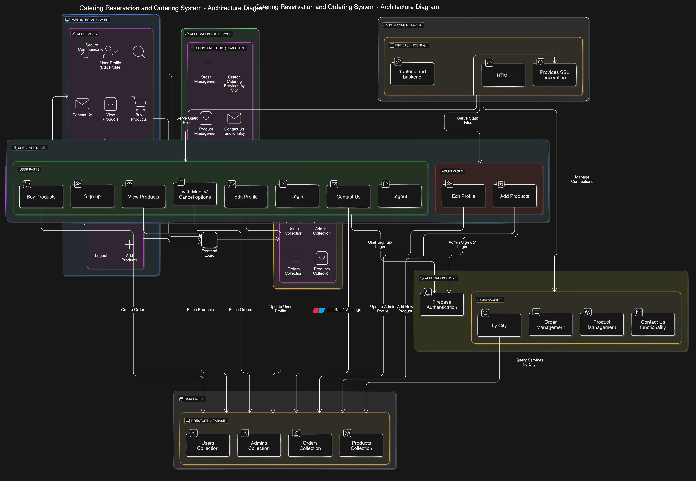

Explanation of the Architecture
The Catering Reservation and Ordering System is built using a layered architecture, which ensures a clear separation of concerns, enhances maintainability, and provides a scalable framework for future development. The architecture consists of four main layers: User Interface, Application Logic, Data, and Deployment. Here's an in-depth explanation of each layer:
1. User Interface Layer
Overview: The User Interface (UI) Layer is the front-facing part of the system, where users (both regular users and admins) interact with the application. It includes all the web pages and components that users see and interact with.
Components:
- User Pages:
  - Sign up/Login: Users can create an account or log into their existing account using email and password. The system differentiates between regular users and admins.
  - User Profile: Users can view and update their profile information such as name, email, mobile number, and city.
  - Search Catering Services by City: Users can search for catering services based on their city. This feature helps users find services near them.
  - View Products: After selecting a city, users can view a list of available catering services/products.
  - Buy Products: Users can place orders for selected catering services/products.
  - Orders: Users can view their order history, request modifications, cancel orders, and check the status of their orders.
  - Contact Us: A page where users can reach out for help or support.
  - Logout: Users can securely log out of the system.
- Admin Pages:
  - Sign up/Login: Similar to user functionality, but for admins.
  - Admin Profile: Admins can update their profile information, including the catering service name, owner name, city, etc.
  - Add Products: Admins can add new catering services/products to the system, which will be visible to users in the selected city.
  - View Orders: Admins can manage orders placed by users, including the ability to modify or cancel orders.
  - Logout: Admins can securely log out of the system.
Purpose: The UI Layer ensures a user-friendly and intuitive experience for both users and admins, enabling them to interact with the system's features easily.
2. Application Logic Layer
Overview: The Application Logic Layer handles all the core functionalities of the system. It includes the logic for user authentication, profile management, product management, order processing, and communication with the database.
Components:
- Firebase Authentication:
  - Manages the sign-up and login processes for both users and admins.
  - Differentiates between regular users and admins using a boolean flag (isUser and isAdmin) as well as UIDs
- Frontend Logic (JavaScript):
  - User/Admin Profile Management: Handles the update and retrieval of profile information from Firestore.
  - Search Catering Services by City: Executes searches in the Products collection based on the city selected by the user.
  - Order Management: Manages the creation, modification, and cancellation of orders. Updates the Orders collection in Firestore with the relevant data.
  - Product Management: Allows admins to add new products or catering services to the Products collection in Firestore.
  - Contact Us: Manages the submission of user queries and sends them to the admin or support team.
Purpose: The Application Logic Layer is the backbone of the system, ensuring that all functionalities work seamlessly and that data flows correctly between the UI and the database.
3. Data Layer
Overview: The Data Layer is responsible for storing and managing all the data used by the system. It uses Firebase Firestore as the primary database, where all user, admin, product, and order information is stored.
Components:
- Firestore Database:
  - Users Collection: Stores user details including unique IDs, full name, email, city, mobile number, and a boolean flag indicating whether the profile belongs to a regular user (isUser = true).
  - Admins Collection: Stores admin details including unique IDs, catering service name, email, city, mobile number, owner name, and a boolean flag indicating whether the profile belongs to an admin (isAdmin = true).
  - Orders Collection: Stores all orders placed by users, linked to their respective user/admin IDs. Includes order status, requests for modification, and cancellation options.
  - Products Collection: Stores details of catering services/products added by admins, categorized by city for easy searchability.
Purpose: The Data Layer ensures that all the data related to users, admins, products, and orders is securely stored and easily retrievable when needed by the application logic.
4. Deployment Layer
Overview: The Deployment Layer is responsible for hosting and serving the application to end users. It uses Firebase Hosting to deploy and manage the static files, ensuring secure and reliable access to the website.
Components:
- Firebase Hosting:
  - Hosts all static files such as HTML, CSS, and JavaScript, making the website accessible to users and admins.
  - Provides SSL encryption, ensuring that all communications between the client and the server are secure.
  - Handles routing and serves the correct pages based on user actions (e.g., navigating to profile, orders, etc.).
Purpose: The Deployment Layer ensures that the application is live, accessible, and secure, allowing users and admins to interact with the system from any location.

Solution Design
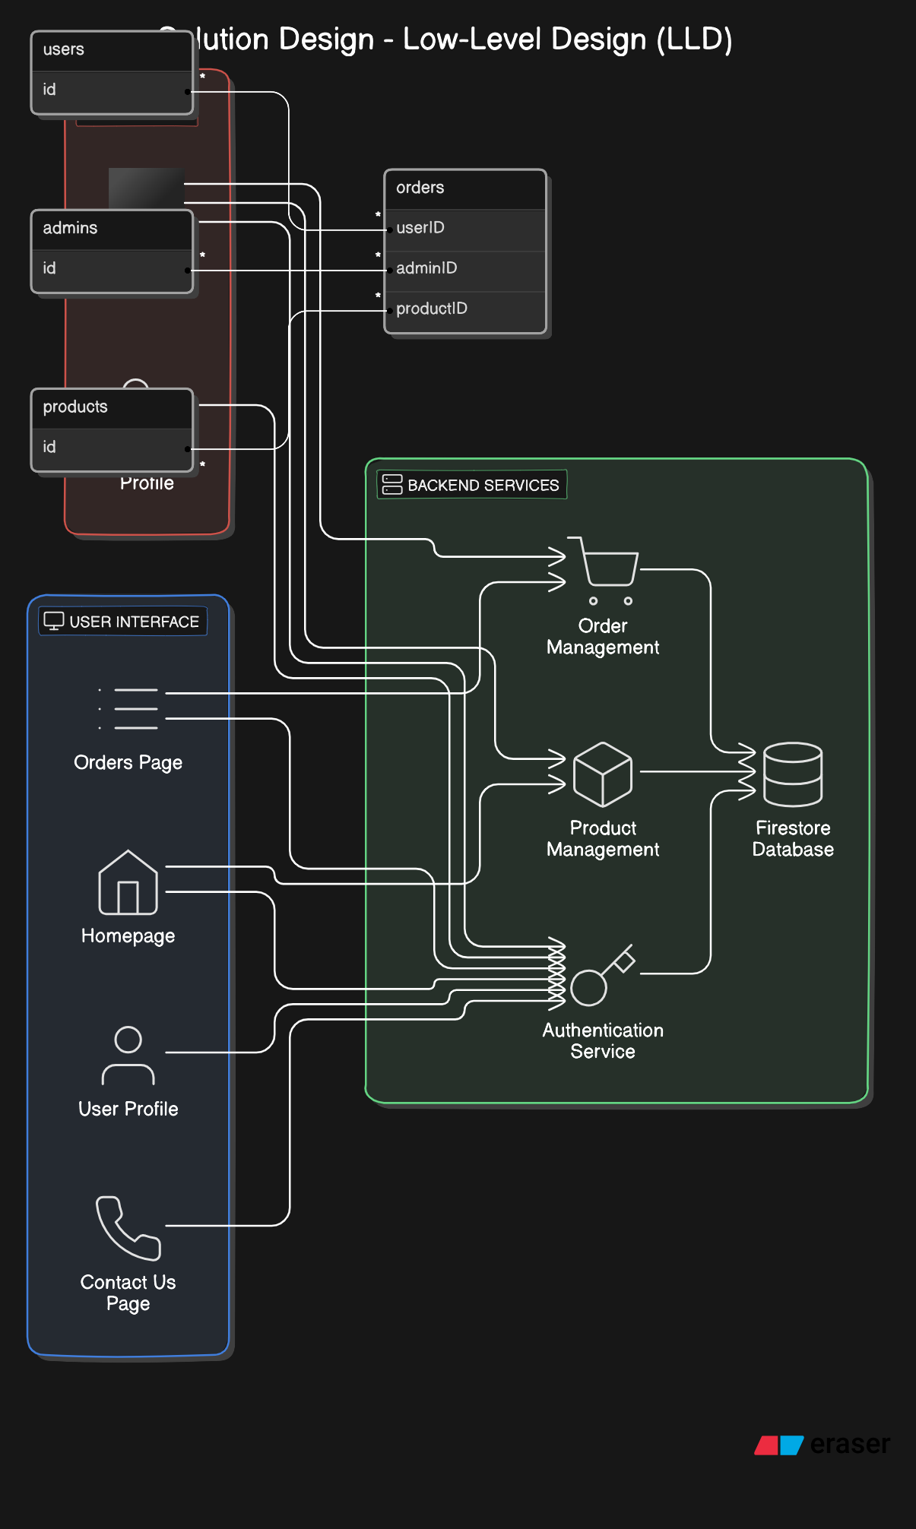
Explanation of the Architecture
Solution Design - Low-Level Design (LLD)
1. Component Diagrams
The system architecture for the Catering Reservation and Ordering System is divided into several key components, each serving a specific function:
- User Interface (UI): This is the front-end layer of the application that interacts directly with users. It includes:
  - Homepage: Provides users with the ability to search for catering services by city and view product details. It also includes navigation to user profile and orders.
  - User Profile: Allows users to edit their personal information, such as name, email, and mobile number.
  - Orders Page: Displays a list of the user’s orders, with options to request modifications or cancel orders.
  - Contact Us Page: Offers a form for users to seek assistance or support.
- Admin Interface: This is the back-end layer for administrators, allowing them to manage products and orders. It includes:
  - Admin Dashboard: Provides tools for managing product listings and monitoring orders.
  - Admin Profile: Enables admins to update their personal and catering service details.
- Backend Services:
  - Authentication Service: Manages user and admin authentication processes, including sign-up and login functionalities.
  - Firestore Database: Stores and organizes data related to users, admins, products, and orders.
  - Product Management: Facilitates the addition, update, and removal of products in the database.
  - Order Management: Handles order creation, updates, and status changes.

Interactions:
- The User Interface interacts with the Backend Services to retrieve and display data, such as products and orders.
- The Admin Interface interacts with the Backend Services to manage products and monitor orders.
- The Authentication Service integrates with Firestore Database to handle user and admin credentials securely.

2. Data Models
The Firestore database schema is designed to manage the data efficiently:
- Users Collection:
  - Document ID (unique): Represents individual user documents.
  - Fields:
    - city: The city where the user is located.
    - email: The user’s email address.
    - fullName: The user’s full name.
    - isUser: Boolean indicating that this document is for a user.
    - mobile: The user’s mobile number.
- Admins Collection:
  - Document ID (unique): Represents individual admin documents.
  - Fields:
    - cateringName: The name of the catering service.
    - city: The city where the admin is located.
    - email: The admin’s email address.
    - isAdmin: Boolean indicating that this document is for an admin.
    - mobile: The admin’s mobile number.
    - ownerName: The name of the admin.
- Products Collection:
  - Document ID (unique): Represents individual product documents.
  - Fields:
    - name: The name of the product.
    - description: The description of the product.
    - price: The price of the product.
    - category: The category of the product.
    - imageURL: The URL of the product image.
- Orders Collection:
  - Document ID (unique): Represents individual order documents.
  - Fields:
    - userID: The ID of the user who placed the order.
    - productID: The ID of the product ordered.
    - quantity: The quantity of the product ordered.
    - status: The current status of the order (e.g., Pending, Completed).
    - orderDate: The date the order was placed.
    - requestModification: Indicates if the order can be modified.
    - cancelOrder: Indicates if the order can be canceled.

3. API Details
Key API Endpoints:
- User Authentication:
  - POST /api/signup: Registers a new user or admin.
    - Request: Contains user/admin details such as email, password, city, and personal information.
    - Response: Success message or error details.
  - POST /api/login: Authenticates a user or admin.
    - Request: Contains email and password.
    - Response: Authentication token and user/admin details.
- Product Management:
  - GET /api/products: Retrieves a list of products.
    - Response: Array of product objects.
  - POST /api/products: Adds a new product (Admin only).
    - Request: Contains product details such as name, description, price, and image URL.
    - Response: Success message or error details.
  - PUT /api/products/:id: Updates product details (Admin only).
    - Request: Contains updated details for the product.
    - Response: Success message or error details.
- Order Management:
  - GET /api/orders: Retrieves orders for a user or admin.
    - Response: Array of order objects.
  - POST /api/orders: Creates a new order.
    - Request: Contains user ID, product ID, and quantity.
    - Response: Success message or order details.
  - PUT /api/orders/:id: Updates the status of an order (Admin only).
    - Request: Contains updated status and any modification or cancellation requests.
    - Response: Success message or error details.

4. UI/UX Designs
Main Pages:
- Homepage: Features a search bar for locating catering services by city and provides access to user profile and orders.
- User Profile: Allows users to modify their personal details.
- Orders Page: Displays a list of user’s orders with modification and cancellation options.
- Contact Us Page: Provides a form for users to request assistance or support.

5. Detailed Design
Additional Design Considerations:
- Error Handling: Error messages are designed to inform users and admins of issues, with appropriate actions for resolution.
- Responsive Design: Ensures that the application adapts to various devices and screen sizes for a consistent user experience.

6. Security and Permissions
Authentication and Authorization Mechanisms:
- Authentication: Managed via Firebase Authentication using email and password.
- Authorization: Role-based access control differentiates between users and admins, with specific permissions for managing products and orders.
Firestore Security Rules:
- Users Collection: Accessible only to the authenticated user who owns the data.
- Admins Collection: Accessible only to authenticated admins with permission to manage products and orders.
- Products Collection: Publicly readable but only writable by admins.
- Orders Collection: Accessible by users for their orders and by admins for all orders.

Testing Strategy for Catering Reservation and Ordering System
1. Introduction
The testing strategy for the Catering Reservation and Ordering System aims to ensure the application’s functionality, performance, and reliability. Testing was conducted throughout the development lifecycle, focusing on individual components, integration between modules, and the overall system.
2. Testing Phases
1. Unit Testing
- Objective: Validate the functionality of individual modules and components in isolation.
- Scope:
  - User Module: Test user signup, login, profile management, and search functionalities.
  - Admin Module: Verify admin signup, login, product management, and order processing.
  - Order Management: Ensure correct handling of order creation, modification requests, and cancellations.
- Approach: Test each function and component separately to confirm they operate as expected.
- Tools Used: JavaScript testing frameworks like Jest or Mocha.
2. Integration Testing
- Objective: Verify that different modules and components work together seamlessly.
- Scope:
  - User and Admin Interactions: Test interactions between user and admin functionalities, such as product viewing by users and product management by admins.
  - Database Integration: Ensure that data is accurately stored and retrieved from Firestore.
  - Authentication Integration: Validate that Firebase Authentication integrates correctly with user and admin authentication systems.
- Approach: Test how well integrated components interact and exchange data.
- Tools Used: Integration testing tools like Postman for API testing and Cypress for end-to-end scenarios.
3. End-to-End Testing
- Objective: Test the complete user journey from start to finish to ensure the system operates as expected.
- Scope:
  - User Journey: Test the entire process from user registration, product search, order placement, and profile management.
  - Admin Journey: Verify admin tasks including product addition, order management, and profile updates.
  - Error Handling: Ensure the application handles errors gracefully and provides meaningful feedback to users.
- Approach: Simulate real user interactions to test the application’s end-to-end functionality.
- Tools Used: Automated testing frameworks like Cypress or Selenium.
4. Manual Testing
- Objective: Identify issues that automated tests may miss and verify the user interface and experience.
- Scope:
  - UI/UX Testing: Ensure the application is visually appealing and functions correctly across different devices and screen sizes.
  - User Experience: Test interactions such as form submissions, navigation, and error messages.
- Approach: Conduct hands-on testing to assess the overall usability and design of the application.
- Tools Used: Browser Developer Tools, cross-browser testing across different web browsers.
5. Performance Testing
- Objective: Evaluate the application’s performance under various conditions to ensure it meets performance requirements.
- Scope:
  - Load Testing: Assess the application’s performance under high traffic to ensure it handles concurrent users efficiently.
  - Stress Testing: Test the application’s behavior under extreme conditions to determine its breaking points.
- Approach: Simulate high load and stress scenarios to evaluate system performance and stability.
- Tools Used: Load testing tools like Apache JMeter or Google Lighthouse.
6. Security Testing
- Objective: Ensure the application is secure and protects against common vulnerabilities.
- Scope:
  - Authentication and Authorization: Verify that only authorized users can access specific features and data.
  - Data Protection: Test for secure handling of sensitive information and compliance with data protection regulations.
- Approach: Conduct security assessments to identify and address potential vulnerabilities.
- Tools Used: Security testing tools like OWASP ZAP or Firebase security features.
7. Regression Testing
- Objective: Ensure that new changes or bug fixes do not negatively impact existing functionalities.
- Scope:
  - Functional Areas: Re-test core functionalities after implementing new features or resolving bugs.
- Approach: Perform regression tests to confirm that previous functionalities continue to work correctly.
- Tools Used: Automated testing frameworks with support for regression scenarios.
8. Conclusion
The testing strategy incorporates a combination of unit, integration, end-to-end, manual, performance, security, and regression testing to ensure a high-quality, reliable Catering Reservation and Ordering System. By following this comprehensive approach, potential issues were identified and resolved, ensuring a robust and user-friendly application.

Deployment

Deployment Steps and Environment

1. Deployment Overview

The Catering Reservation and Ordering System is deployed on Firebase Hosting, which provides a reliable and scalable platform for serving web applications. Firebase Hosting offers secure hosting with SSL certificates, global content delivery, and seamless integration with Firebase services.

2. Prerequisites

Firebase Account: Ensure you have a Firebase account and a Firebase project set up in the [Firebase Console](https://console.firebase.google.com/).
Firebase CLI: Install the Firebase Command Line Interface (CLI) to interact with Firebase services from the command line.
Node.js and npm: Ensure Node.js and npm are installed on your local machine to manage dependencies and execute deployment commands.

3. Deployment Steps
1. Set Up Firebase CLI
Install Firebase CLI: Open your command line interface (CMD or terminal) and run the following command to install the Firebase CLI globally:
npm install -g firebase-tools

Login to Firebase: Authenticate with your Firebase account using the CLI:
firebase login

2. Initialize Firebase Project

Navigate to Project Directory: Change to your project directory where your website files are located:
cd path/to/your/project
Initialize Firebase: Run the Firebase initialization command to set up your Firebase project:
firebase init
Select Firebase Features: Choose "Hosting" and other relevant features (like Firestore or Functions) as needed.
Select Project: Choose the Firebase project you created in the Firebase Console.
Configure Hosting: Specify the public directory where your build files are located (e.g., `public` or `dist`).

3. Build Project

Prepare Build Files: Ensure your website files (HTML, CSS, JS) are ready for deployment. If using a build tool (like Webpack or a task runner), generate the production build files:
npm run build
or manually place your files in the designated public directory.

4. Deploy to Firebase

Deploy Command: Deploy your project to Firebase Hosting by running:
firebase deploy
Review Deployment: The CLI will provide a URL where your deployed website can be accessed. Review the deployment output for any errors or warnings.

5. Post-Deployment

Verify Deployment: Visit the provided Firebase Hosting URL to ensure your website is live and functioning as expected.
Monitor Hosting: Use the Firebase Console to monitor your hosting environment, check deployment history, and manage site settings.

4. Deployment Environment

Firebase Hosting: The application is hosted on Firebase Hosting, which provides a global content delivery network (CDN) for fast and secure access to your site. Firebase Hosting automatically handles SSL certificates and ensures secure connections.
Firestore Database: Firebase Firestore is used to store and manage data for users, admins, products, and orders. Firestore provides real-time updates and scalability for your application.
Firebase Authentication: Firebase Authentication handles user and admin authentication, ensuring secure access to different parts of the application.

Deploying the Catering Reservation and Ordering System on Firebase Hosting ensures a secure, scalable, and efficient delivery of the application to users. The deployment process involves setting up Firebase CLI, initializing the project, building the application, and deploying it to Firebase Hosting. Regular monitoring and maintenance of the hosting environment ensure the continued performance and security of the application.

Conclusion
The Catering Reservation and Ordering System project represents a significant achievement in creating a dynamic and user-friendly platform for both catering service providers and consumers. By leveraging HTML, CSS, JavaScript, and Firebase, the project successfully integrates a variety of features essential for managing catering services efficiently. The system was designed with a clear focus on modularity and maintainability, ensuring that both users and administrators can navigate and manage the system with ease. Users benefit from functionalities such as searching for services by city, viewing product details, and placing orders, while admins have the capability to manage product listings and oversee order processes.
Throughout the development process, the system underwent rigorous testing to ensure functionality and reliability. Module-level testing during development phases, followed by comprehensive end-to-end testing upon project completion, helped identify and address issues, leading to a robust and stable application. This approach ensured that the system performs effectively in a live environment, with all components functioning as intended. The use of Firebase for authentication, real-time database management, and hosting provided a seamless and scalable solution, enhancing the overall user experience.
The deployment of the project on Firebase Hosting marks the successful completion of a well-designed and implemented web application. The deployment process involved using Firebase CLI tools to initialize, build, and deploy the project, which was executed smoothly with continuous monitoring for performance and security. The project's success not only demonstrates the capabilities of modern web technologies and cloud services but also highlights the potential for future enhancements to further expand the system's features and improve its functionality. Overall, the Catering Reservation and Ordering System stands as a testament to effective project management and technical expertise in developing impactful web applications.

Future Work and Enhancements
- Enhanced Contact Us Page:
  - Admin Reporting: Expand the existing "Contact Us" page functionality to include a report/issue submission option for admins. This will enable admins to receive and address issues or feedback directly. These reports will be saved in a Firestore document, allowing for efficient tracking and management of admin-related concerns.
- Expanded City Search Functionality:
  - Increased Reach: Enhance the search functionality to include a broader range of cities. This will facilitate users from more regions to access and utilize catering services, thereby expanding the reach of the platform and attracting a larger user base.
- Enhanced User and Admin Profiles:
  - User Profile Enhancements: Add additional options and features to the user profile page, such as preferences or subscription settings, to provide a more personalized experience.
  - Admin Profile Details: Include more detailed information in the admin profile, such as business credentials or service specialties, to enhance transparency and user trust.
- Product Photo Integration:
  - Visual Representation: Allow admins to upload and display product photos for each product listed. This visual enhancement will provide users with a better understanding of the products and improve the overall user experience.
- Advanced Reporting and Analytics:
  - Dashboard Integration: Implement a comprehensive reporting and analytics dashboard for admins to track key metrics such as sales, order trends, and user engagement. This will aid in better decision-making and operational efficiency.
- Improved User Interface:
  - Design Upgrades: Continuously refine the user interface and experience based on user feedback and emerging design trends. This could include optimizing page layouts, improving navigation, and enhancing mobile responsiveness.
- Automated Notifications:
  - Alert System: Introduce automated notifications for users and admins regarding order status updates, product availability, and special promotions. This will keep users informed and engaged with the platform.

Appendices and Code Listings
admin_signup.html :
<!DOCTYPE html>
<html lang="en">

<head>
<meta charset="UTF-8">
<meta name="viewport" content="width=device-width, initial-scale=1.0">
<title>Admin Signup - Catering Reservation and Ordering System</title>
<link rel="stylesheet" href="css/style.css">
</head>

<body>
<header>
<nav>
<ul class="navbar">
<li class="logo"><a href="index.html"><img src="images/logo.png" alt="Website Logo"></a></li>
</ul>
</nav>
</header>
<main>
<section class="admin-signup-form">
<h2>Admin Signup</h2>
<form id="adminSignupForm">
<div class="form-group">
<label for="email">Email Address</label>
<input type="email" id="email" name="email" required>
</div>
<div class="form-group">
<label for="password">Password</label>
<input type="password" id="password" name="password" required>
</div>
<div class="form-group">
<label for="catering-name">Catering Service Name</label>
<input type="text" id="catering-name" name="catering-name" required>
</div>
<div class="form-group">
<label for="city">City</label>
<input type="text" id="city" name="city" required>
</div>
<div class="form-group">
<label for="mobile">Mobile Number</label>
<input type="tel" id="mobile" name="mobile" pattern="[0-9]{10}" required>
</div>
<div class="form-group">
<label for="owner-name">Owner Name</label>
<input type="text" id="owner-name" name="owner-name" required>
</div>
<button type="submit">Signup</button>
</form>
</section>
</main>
<footer>
<p>&copy; 2024 Catering Reservation and Ordering System</p>
</footer>
<script type="module">
// Import the functions you need from the SDKs you need
import { initializeApp } from "https://www.gstatic.com/firebasejs/10.13.1/firebase-app.js";
import { getAuth, createUserWithEmailAndPassword } from "https://www.gstatic.com/firebasejs/10.13.1/firebase-auth.js";
import { getFirestore, doc, setDoc } from "https://www.gstatic.com/firebasejs/10.13.1/firebase-firestore.js";

// Your Firebase configuration
const firebaseConfig = {
apiKey: "YOUR_API_KEY",
authDomain: "YOUR_AUTH_DOMAIN",
projectId: "YOUR_PROJECT_ID",
storageBucket: "YOUR_STORAGE_BUCKET",
messagingSenderId: "YOUR_MESSAGING_SENDER_ID",
appId: "YOUR_APP_ID",
measurementId: "YOUR_MEASUREMENT_ID"
};

// Initialize Firebase
const app = initializeApp(firebaseConfig);
const auth = getAuth(app);
const db = getFirestore(app);

// Event listener for form submission
document.addEventListener('DOMContentLoaded', () => {
const adminSignupForm = document.getElementById('adminSignupForm');

adminSignupForm.addEventListener('submit', async (e) => {
e.preventDefault();

const email = adminSignupForm['email'].value;
const password = adminSignupForm['password'].value;
const cateringName = adminSignupForm['catering-name'].value;
const city = adminSignupForm['city'].value;
const mobile = adminSignupForm['mobile'].value;
const ownerName = adminSignupForm['owner-name'].value;

try {
// Create user with email and password
const userCredential = await createUserWithEmailAndPassword(auth, email, password);
const user = userCredential.user;

// Store additional user data in Firestore
await setDoc(doc(db, 'admins', user.uid), {
email: email,
cateringName: cateringName,
city: city,
mobile: mobile,
ownerName: ownerName,
isAdmin: true
});

// Redirect to admin home page after successful signup
window.location.href = 'admin_home.html';
} catch (error) {
console.error("Error during signup:", error.message);
alert(`Signup failed: ${error.message}`);
}
});
});
</script>
</body>

</html>

admin_orders.js :
// Import the functions you need from the Firebase SDK
import { initializeApp } from 'https://www.gstatic.com/firebasejs/10.13.1/firebase-app.js';
import { getAuth, onAuthStateChanged } from 'https://www.gstatic.com/firebasejs/10.13.1/firebase-auth.js';
import { getFirestore, collection, query, where, getDocs, doc, getDoc, updateDoc } from 'https://www.gstatic.com/firebasejs/10.13.1/firebase-firestore.js';

// Firebase configuration
const firebaseConfig = {
apiKey: "YOUR_API_KEY",
authDomain: "YOUR_AUTH_DOMAIN",
projectId: "YOUR_PROJECT_ID",
storageBucket: "YOUR_STORAGE_BUCKET",
messagingSenderId: "YOUR_MESSAGING_SENDER_ID",
appId: "YOUR_APP_ID",
measurementId: "YOUR_MEASUREMENT_ID"
};
// Initialize Firebase
const app = initializeApp(firebaseConfig);
const auth = getAuth(app);
const db = getFirestore(app);

document.addEventListener('DOMContentLoaded', function () {
const ordersTbody = document.getElementById('orders-tbody');
const userName = document.getElementById('user-name');
const userEmail = document.getElementById('user-email');
const userAddress = document.getElementById('user-address');

onAuthStateChanged(auth, async (user) => {
if (user) {
const userId = user.uid;
console.log('Current user UID:', userId); // Log the user ID

try {
// Fetch orders for the logged-in user
const ordersQuery = query(collection(db, 'orders'));
const querySnapshot = await getDocs(ordersQuery);

for (const docSnap of querySnapshot.docs) {
const order = docSnap.data();
const row = document.createElement('tr');

const orderIdCell = document.createElement('td');
orderIdCell.textContent = docSnap.id; // Use document ID as Order ID
row.appendChild(orderIdCell);

const orderDateCell = document.createElement('td');
orderDateCell.textContent = order.orderDate.toDate().toLocaleDateString(); // Format date as needed
row.appendChild(orderDateCell);

const orderDetailsCell = document.createElement('td');
const productRef = doc(db, 'products', order.productId);
const productDoc = await getDoc(productRef);
if (productDoc.exists()) {
const productData = productDoc.data();
orderDetailsCell.textContent = `Product: ${productData.name}, Price: ₹${productData.price}`;
} else {
orderDetailsCell.textContent = 'Product details not found';
}
row.appendChild(orderDetailsCell);

const statusCell = document.createElement('td');
statusCell.textContent = order.status;
row.appendChild(statusCell);

const actionsCell = document.createElement('td');

// Request Modification button
const requestModificationButton = document.createElement('button');
requestModificationButton.className = 'action-btn';
requestModificationButton.textContent = 'Request Modification';
requestModificationButton.onclick = () => requestModification(docSnap.id);
actionsCell.appendChild(requestModificationButton);

// Request Cancellation button
const requestCancellationButton = document.createElement('button');
requestCancellationButton.className = 'action-btn';
requestCancellationButton.textContent = 'Cancel Order';
requestCancellationButton.onclick = () => cancelOrder(docSnap.id);
actionsCell.appendChild(requestCancellationButton);

row.appendChild(actionsCell);
ordersTbody.appendChild(row);
}

// Fetch user details and populate them
const userDoc = await getDoc(doc(db, 'users', userId));
if (userDoc.exists()) {
const userData = userDoc.data();
userName.textContent = userData.name || "Name not provided";
userEmail.textContent = userData.email || "Email not provided";
userAddress.textContent = userData.address || "Address not provided";
} else {
console.log("No such user!");
}
} catch (error) {
console.error('Error fetching orders:', error);
}
} else {
// Redirect to login page if user is not authenticated
window.location.href = 'index.html';
}
});

async function requestModification(orderId) {
console.log('Requesting modification for order:', orderId);

const orderRef = doc(db, 'orders', orderId);
try {
await updateDoc(orderRef, {
status: 'Modification Requested'
});
alert('Modification request submitted.');
} catch (error) {
console.error('Error requesting modification:', error);
}
}

async function cancelOrder(orderId) {
console.log('Cancelling order:', orderId);

const orderRef = doc(db, 'orders', orderId);
try {
await updateDoc(orderRef, {
status: 'Cancelled'
});
alert('Order has been cancelled.');
} catch (error) {
console.error('Error cancelling order:', error);
}
}
});

Admin_products.js :
import { initializeApp } from "https://www.gstatic.com/firebasejs/10.13.1/firebase-app.js";
import { getAuth, onAuthStateChanged } from "https://www.gstatic.com/firebasejs/10.13.1/firebase-auth.js";
import { getFirestore, collection, addDoc, getDocs, query, where } from "https://www.gstatic.com/firebasejs/10.13.1/firebase-firestore.js";

// Firebase configuration
const firebaseConfig = {
apiKey: "YOUR_API_KEY",
authDomain: "YOUR_AUTH_DOMAIN",
projectId: "YOUR_PROJECT_ID",
storageBucket: "YOUR_STORAGE_BUCKET",
messagingSenderId: "YOUR_MESSAGING_SENDER_ID",
appId: "YOUR_APP_ID",
measurementId: "YOUR_MEASUREMENT_ID"
};
// Initialize Firebase
const app = initializeApp(firebaseConfig);
const auth = getAuth(app);
const db = getFirestore(app);

document.addEventListener("DOMContentLoaded", () => {
const addProductForm = document.getElementById("add-product-form");
const productList = document.getElementById("product-list");

onAuthStateChanged(auth, async (user) => {
if (user) {
user.getIdTokenResult().then((idTokenResult) => {
console.log("Token claims:", idTokenResult.claims);
});

// Listen for form submission
addProductForm.addEventListener("submit", async (event) => {
event.preventDefault();

// Get form values
const productName = document.getElementById("product-name").value;
const productCategory = document.getElementById("product-category").value;
const productDescription = document.getElementById("product-description").value;
const productPrice = parseFloat(document.getElementById("product-price").value);
const productCity = document.getElementById("product-city").value;

try {
// Add product to Firestore
await addDoc(collection(db, "products"), {
name: productName,
category: productCategory,
description: productDescription,
price: productPrice,
city: productCity,
adminId: user.uid // Associate the product with the admin
});

// Clear form after successful submission
addProductForm.reset();
alert("Product added successfully!");

// Refresh product list
displayProducts(user.uid);
} catch (error) {
console.error("Error adding product: ", error);
alert("Failed to add product.");
}
});
} else {
// Redirect to login page if not authenticated
window.location.href = "admin_login.html";
}
});

async function displayProducts(adminId) {
try {
// Clear current product list
productList.innerHTML = "";

// Fetch products from Firestore for the logged-in admin
const productsQuery = query(collection(db, "products"), where("adminId", "==", adminId));
const querySnapshot = await getDocs(productsQuery);
querySnapshot.forEach((doc) => {
const product = doc.data();

// Create a div to display the product
const productDiv = document.createElement("div");
productDiv.classList.add("product-item");
productDiv.innerHTML = `
<h3>${product.name}</h3>
<p>Category: ${product.category}</p>
<p>Description: ${product.description}</p>
<p>Price: ₹${product.price.toFixed(2)}</p>
<p>City: ${product.city}</p>
`;
productList.appendChild(productDiv);
});
} catch (error) {
console.error("Error fetching products: ", error);
alert("Failed to load products.");
}
}
});

User_login.html :
<!DOCTYPE html>
<html lang="en">

<head>
<meta charset="UTF-8">
<meta name="viewport" content="width=device-width, initial-scale=1.0">
<title>User Login - Catering Reservation and Ordering System</title>
<link rel="stylesheet" href="css/style.css">
<script type="module">
import { initializeApp } from "https://www.gstatic.com/firebasejs/10.13.1/firebase-app.js";
import { getAuth, signInWithEmailAndPassword } from "https://www.gstatic.com/firebasejs/10.13.1/firebase-auth.js";
import { getFirestore, doc, getDoc } from "https://www.gstatic.com/firebasejs/10.13.1/firebase-firestore.js";

const firebaseConfig = {
apiKey: "YOUR_API_KEY",
authDomain: "YOUR_AUTH_DOMAIN",
projectId: "YOUR_PROJECT_ID",
storageBucket: "YOUR_STORAGE_BUCKET",
messagingSenderId: "YOUR_MESSAGING_SENDER_ID",
appId: "YOUR_APP_ID",
measurementId: "YOUR_MEASUREMENT_ID"
};

const app = initializeApp(firebaseConfig);
const auth = getAuth(app);
const db = getFirestore(app);

// User Login Functionality
document.addEventListener('DOMContentLoaded', () => {
const userLoginForm = document.getElementById('userLoginForm');

userLoginForm.addEventListener('submit', async (e) => {
e.preventDefault();

const email = userLoginForm['user-email'].value;
const password = userLoginForm['user-password'].value;

try {
const userCredential = await signInWithEmailAndPassword(auth, email, password);
const user = userCredential.user;

const userDoc = await getDoc(doc(db, 'users', user.uid));

if (userDoc.exists()) {
window.location.href = 'user_home.html';
} else {
alert('No user account found. Please sign up.');
}
} catch (error) {
console.error('Error signing in user:', error);
alert('Failed to login user. Please try again.');
}
});
});
</script>
</head>

<body>
<header>
<nav>
<ul class="navbar">
<li class="logo"><a href="index.html"><img src="images/logo.png" alt="Website Logo"></a></li>
</ul>
</nav>
</header>
<main>
<section class="user-login-form">
<h2>User Login</h2>
<form id="userLoginForm">
<div class="form-group">
<label for="user-email">Email Address</label>
<input type="email" id="user-email" name="user-email" required>
</div>
<div class="form-group">
<label for="user-password">Password</label>
<input type="password" id="user-password" name="user-password" required>
</div>
<button type="submit">Login</button>
</form>
</section>
</main>
<footer>
<p>&copy; 2024 Catering Reservation and Ordering System</p>
</footer>
</body>

</html>
user_profile :
<!DOCTYPE html>
<html lang="en">

<head>
<meta charset="UTF-8">
<meta name="viewport" content="width=device-width, initial-scale=1.0">
<title>User Profile</title>
<link rel="stylesheet" href="css/user_profile.css">
</head>

<body>
<div class="profile-container">
<h2>User Profile</h2>
<form id="user-profile-form">
<label for="fullName">Full Name</label>
<input type="text" id="fullName" name="fullName" required>

<label for="email">Email</label>
<input type="email" id="email" name="email" readonly>

<label for="city">City</label>
<input type="text" id="city" name="city" required>

<label for="mobile">Mobile Number</label>
<input type="tel" id="mobile" name="mobile" required>

<button type="submit">Save Changes</button>
</form>
</div>

<script type="module">
import { initializeApp } from "https://www.gstatic.com/firebasejs/10.13.1/firebase-app.js";
import { getFirestore, doc, getDoc, updateDoc } from "https://www.gstatic.com/firebasejs/10.13.1/firebase-firestore.js";
import { getAuth, onAuthStateChanged } from "https://www.gstatic.com/firebasejs/10.13.1/firebase-auth.js";

const firebaseConfig = {
apiKey: "YOUR_API_KEY",
authDomain: "YOUR_AUTH_DOMAIN",
projectId: "YOUR_PROJECT_ID",
storageBucket: "YOUR_STORAGE_BUCKET",
messagingSenderId: "YOUR_MESSAGING_SENDER_ID",
appId: "YOUR_APP_ID",
measurementId: "YOUR_MEASUREMENT_ID"
};

const app = initializeApp(firebaseConfig);
const db = getFirestore(app);
const auth = getAuth(app);

document.addEventListener('DOMContentLoaded', () => {
const form = document.getElementById('user-profile-form');

onAuthStateChanged(auth, async (user) => {
if (user) {
const docRef = doc(db, "users", user.uid);
const docSnap = await getDoc(docRef);

if (docSnap.exists()) {
const data = docSnap.data();
form.fullName.value = data.fullName || '';
form.email.value = data.email || '';
form.city.value = data.city || '';
form.mobile.value = data.mobile || '';
}

form.addEventListener('submit', async (e) => {
e.preventDefault();
try {
await updateDoc(docRef, {
fullName: form.fullName.value,
city: form.city.value,
mobile: form.mobile.value
});
alert("Profile updated successfully!");
} catch (error) {
console.error("Error updating profile:", error);
alert("Failed to update profile.");
}
});
} else {
window.location.href = "index.html";
}
});
});
</script>
</body>

</html>
user_home.html :
<!DOCTYPE html>
<html lang="en">

<head>
<meta charset="UTF-8">
<meta name="viewport" content="width=device-width, initial-scale=1.0">
<title>User Home - Catering Reservation and Ordering System</title>
<link rel="stylesheet" href="css/style.css">
</head>

<body>
<header>
<nav>
<ul class="navbar">
<li class="logo"><a href="user_home.html"><img src="images/logo.png" alt="Website Logo"></a></li>
<li class="dropdown">
<a href="#ServicesCategories" class="dropbtn">Catering Services For</a>
<div class="dropdown-content">
<a href="#marriage-wedding">Marriage-Wedding Party Catering</a>
<a href="#birthday">Birthday Party Catering</a>
<a href="#corporate-Office">Corporate-Office Party Catering</a>
<a href="#School-college">School-College Function Catering</a>
<a href="#buffet">Buffet Catering</a>
<a href="#outdoor">Outdoor Catering</a>
<a href="#party">Party Catering</a>
</div>
</li>
<li><a href="contact_us.html">Contact Us</a></li>
<li class="search-bar"><input type="text" placeholder="Search.."></li>
<li class="dropdown">
<a href="#user-account" class="dropbtn">My Account</a>
<div class="dropdown-content">
<a href="user_profile.html">Profile</a>
<a href="user_orders.html">My Orders</a>
<a href="#" id="logout-button">Logout</a>
</div>
</li>
<li class="icon-item">
<a href="user_orders.html">
<img src="images/cart.png" alt="Shopping Cart">
</a>
</li>
</ul>
</nav>
</header>
<section class="banner">
<img src="images/banner.jpg" alt="Banner Img">
<div class="banner-content">
<h1>Welcome, <span id="user-name"></span>!</h1>
<form id="search-form">
<select id="city-select">
<option value="">Select City</option>
<option value="Mumbai">Mumbai</option>
<option value="Delhi">Delhi</option>
<option value="Bangalore">Bangalore</option>
<option value="Chennai">Chennai</option>
</select>
<select id="category-select">
<option value="">Select Catering Service Category</option>
<option value="Marriage">Marriage-Wedding Party Catering</option>
<option value="Birthday">Birthday Party Catering</option>
<option value="Corporate">Corporate-Office Party Catering</option>
<option value="School">School-College Function Catering</option>
<option value="Buffet">Buffet Catering</option>
<option value="Outdoor">Outdoor Catering</option>
<option value="Party">Party Catering</option>
</select>
<button type="button" id="search-button">Search</button>
</form>
<!-- Add search results container -->
<div id="search-results"></div>
</div>
</section>
<main>
<h2>About Our Service</h2>
<p>This platform allows rural towns to sell their commodities globally, promoting traditional Indian culture
through catering services.</p>
</main>
<footer>
<p>&copy; 2024 Catering Reservation and Ordering System</p>
</footer>

<!-- Firebase and App Scripts -->
<script type="module">
// Import Firebase modules
import { initializeApp } from "https://www.gstatic.com/firebasejs/10.13.1/firebase-app.js";
import { getAuth, onAuthStateChanged, signOut } from "https://www.gstatic.com/firebasejs/10.13.1/firebase-auth.js";
import { getFirestore, doc, getDoc } from "https://www.gstatic.com/firebasejs/10.13.1/firebase-firestore.js";

// Initialize Firebase configuration
const firebaseConfig = {
apiKey: "YOUR_API_KEY",
authDomain: "YOUR_AUTH_DOMAIN",
projectId: "YOUR_PROJECT_ID",
storageBucket: "YOUR_STORAGE_BUCKET",
messagingSenderId: "YOUR_MESSAGING_SENDER_ID",
appId: "YOUR_APP_ID",
measurementId: "YOUR_MEASUREMENT_ID"
};
// Initialize Firebase app and services
const app = initializeApp(firebaseConfig);
const auth = getAuth(app);
const db = getFirestore(app); // Ensure db is initialized here

document.addEventListener('DOMContentLoaded', () => {
const userNameElement = document.getElementById('user-name');
const logoutButton = document.getElementById('logout-button');

onAuthStateChanged(auth, async (user) => {
if (user) {
try {
// Attempt to fetch user document from Firestore
const userDoc = await getDoc(doc(db, 'users', user.uid));
if (userDoc.exists()) {
const userData = userDoc.data();
userNameElement.textContent = userData.fullName || "User";
} else {
console.log("No user document found.");
}
} catch (error) {
console.error("Error fetching user document:", error);
}
} else {
window.location.href = 'index.html'; // Redirect if user not signed in
}
});

logoutButton.addEventListener('click', async (e) => {
e.preventDefault();
try {
await signOut(auth);
window.location.href = 'index.html';
} catch (error) {
console.error('Error logging out:', error.message);
}
});

const searchButton = document.getElementById('search-button');

searchButton.addEventListener('click', () => {
const city = document.getElementById('city-select').value;
const category = document.getElementById('category-select').value;

if (city && category) {
window.location.href = `search_results.html?city=${encodeURIComponent(city)}&category=${encodeURIComponent(category)}`;
} else {
alert('Please select both city and category');
}
});
});
</script>
</body>

</html>
search_results.js :
import { initializeApp } from "https://www.gstatic.com/firebasejs/10.13.1/firebase-app.js";
import { getAuth, onAuthStateChanged } from "https://www.gstatic.com/firebasejs/10.13.1/firebase-auth.js";
import { getFirestore, collection, query, where, getDocs, doc, getDoc, addDoc } from "https://www.gstatic.com/firebasejs/10.13.1/firebase-firestore.js";

const firebaseConfig = {
apiKey: "YOUR_API_KEY",
authDomain: "YOUR_AUTH_DOMAIN",
projectId: "YOUR_PROJECT_ID",
storageBucket: "YOUR_STORAGE_BUCKET",
messagingSenderId: "YOUR_MESSAGING_SENDER_ID",
appId: "YOUR_APP_ID",
measurementId: "YOUR_MEASUREMENT_ID"
};
const app = initializeApp(firebaseConfig);
const auth = getAuth(app);
const db = getFirestore(app);

document.addEventListener('DOMContentLoaded', () => {
const searchParams = new URLSearchParams(window.location.search);
const city = searchParams.get('city');
const category = searchParams.get('category');
const searchResultsElement = document.getElementById('search-results');

if (!city || !category) {
searchResultsElement.textContent = 'No city or category selected.';
return;
}

// Ensure the user is authenticated before proceeding
onAuthStateChanged(auth, (user) => {
if (user) {
fetchCateringServices(city, category, user.uid);
} else {
searchResultsElement.textContent = 'You need to be logged in to view services.';
}
});
});

async function fetchCateringServices(city, category, userId) {
const searchResultsElement = document.getElementById('search-results');

try {
// Query admins based on the city
const adminsRef = collection(db, 'admins');
const adminQuery = query(adminsRef, where('city', '==', city));
const adminSnapshot = await getDocs(adminQuery);

if (adminSnapshot.empty) {
searchResultsElement.textContent = 'No services found for the selected criteria.';
} else {
const resultsHtml = await Promise.all(adminSnapshot.docs.map(async (adminDoc) => {
const adminData = adminDoc.data();
const productsRef = collection(db, 'products');

// Query products based on the admin ID and category
const productsQuery = query(productsRef, where('adminId', '==', adminDoc.id), where('category', '==', category));
const productsSnapshot = await getDocs(productsQuery);

if (productsSnapshot.empty) {
return ''; // No products for this admin in the given category
}

return productsSnapshot.docs.map(productDoc => {
const productData = productDoc.data();
return `
<div class="service-item">
<h3>${adminData.cateringName}</h3>
<p>Product: ${productData.name}</p>
<p>Description: ${productData.description}</p>
<p>Price: ₹${productData.price}</p>
<button class="buy-btn" data-product-id="${productDoc.id}" data-admin-id="${adminDoc.id}">Buy</button>
</div>
`;
}).join('');
}));

searchResultsElement.innerHTML = resultsHtml.filter(html => html !== '').join('');
}
} catch (error) {
console.error('Error fetching search results:', error.message);
searchResultsElement.textContent = 'An error occurred while fetching search results.';
}
}

// Event listener for buy buttons
document.addEventListener('click', async (event) => {
if (event.target.classList.contains('buy-btn')) {
const productId = event.target.getAttribute('data-product-id');
const adminId = event.target.getAttribute('data-admin-id');
const userId = auth.currentUser ? auth.currentUser.uid : null;

if (!userId) {
alert('You need to be logged in to place an order.');
return;
}

try {
// Add order to Firestore
await addDoc(collection(db, 'orders'), {
userId,
adminId,
productId,
status: 'Pending',
orderDate: new Date(),
});

alert('Order placed successfully!');
} catch (error) {
console.error('Error placing order:', error);
alert('An error occurred while placing the order.');
}
}
});

Outputs :
Admin Modules :
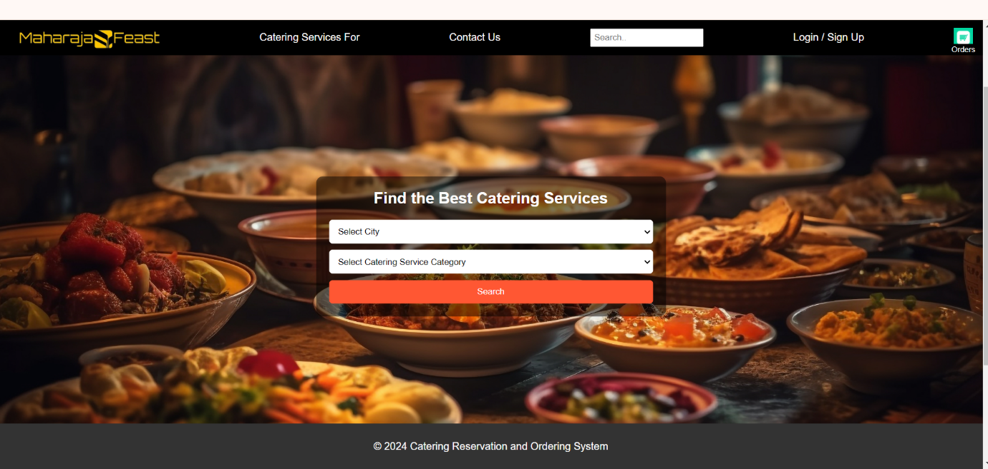

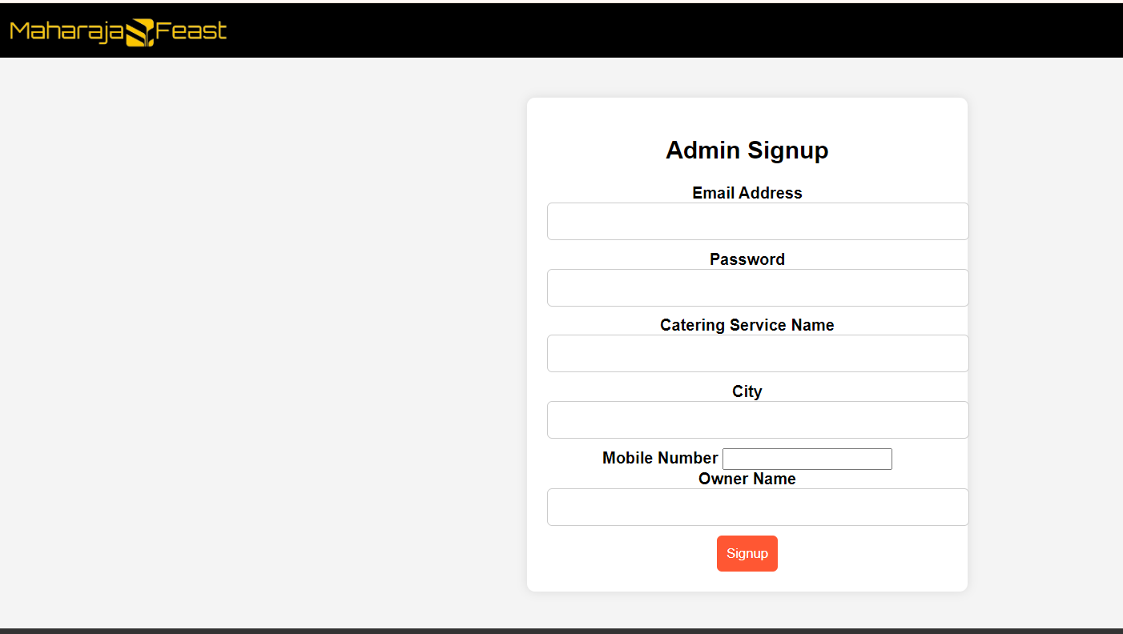

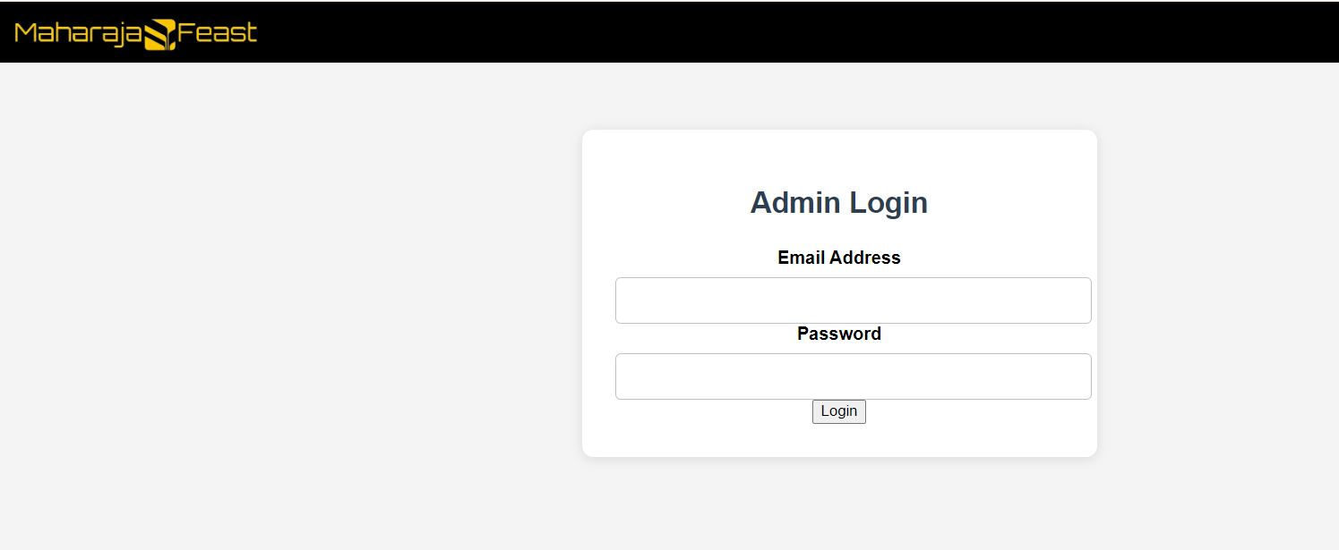

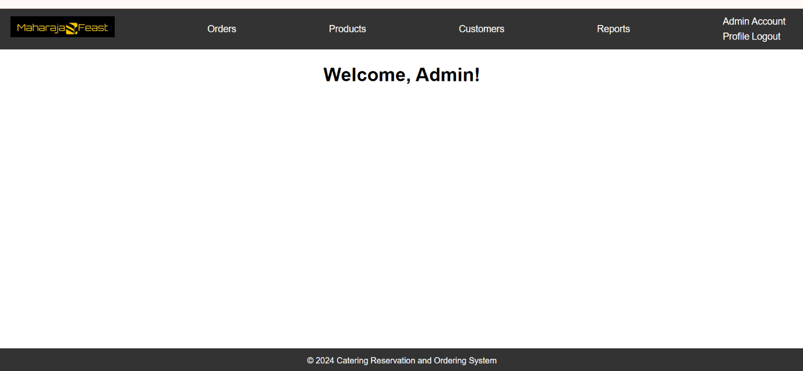
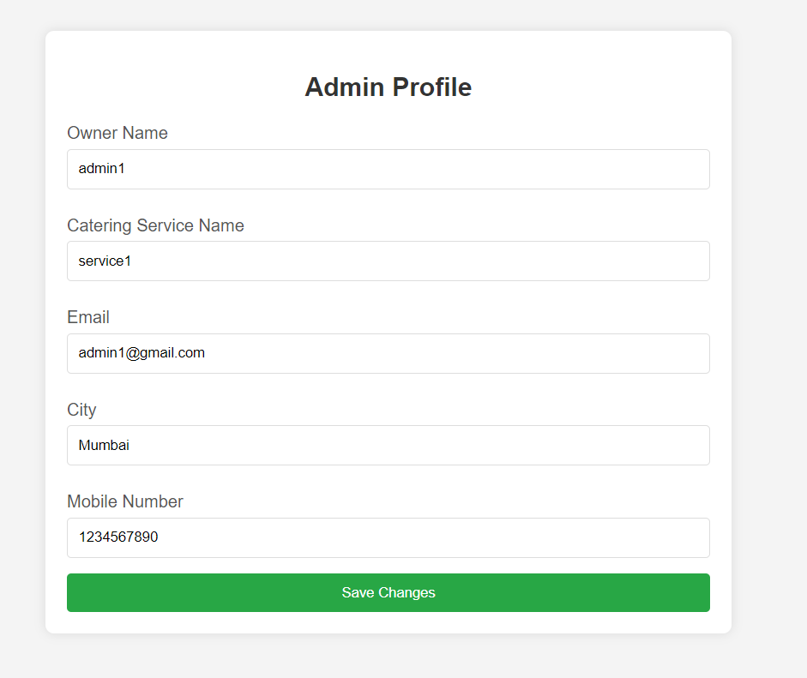

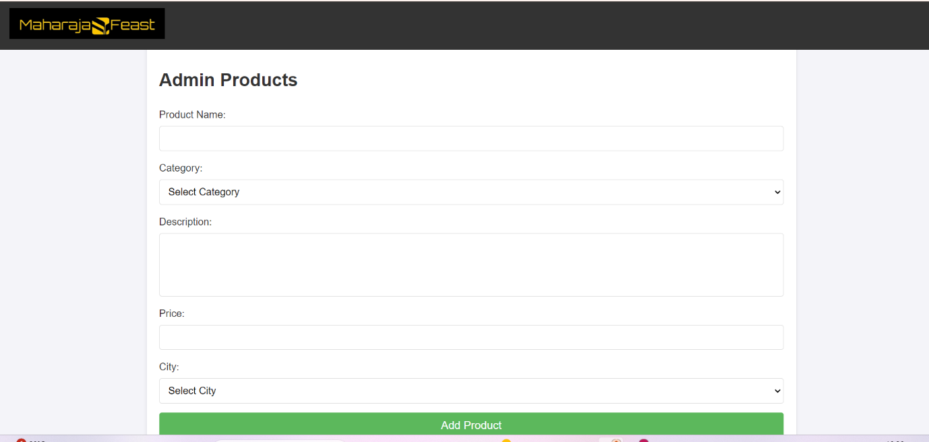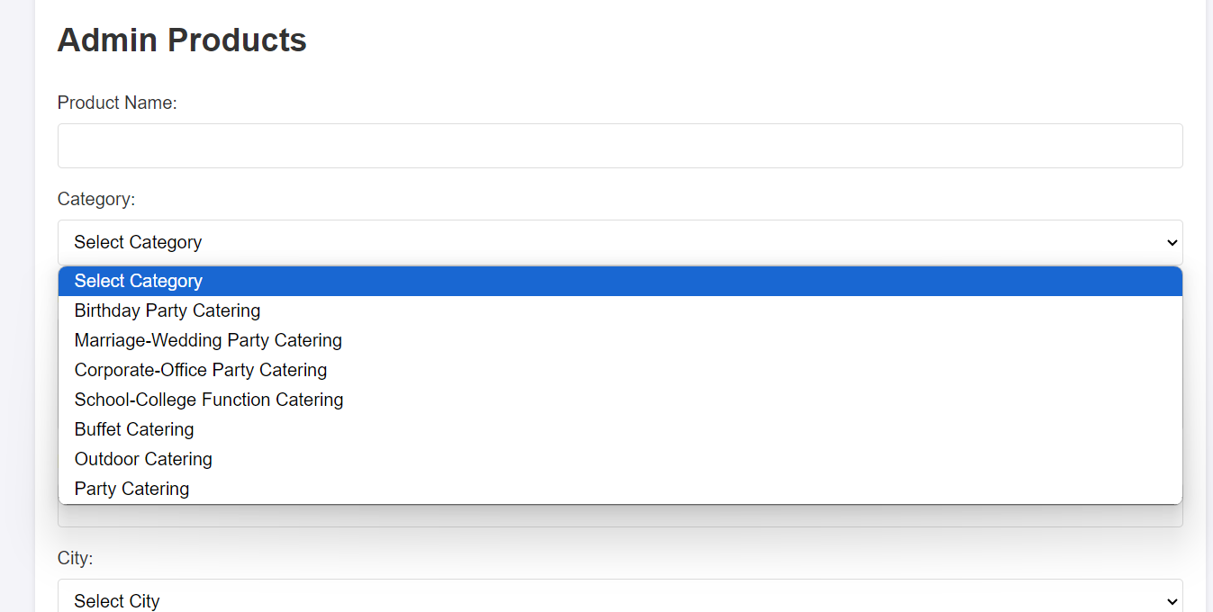

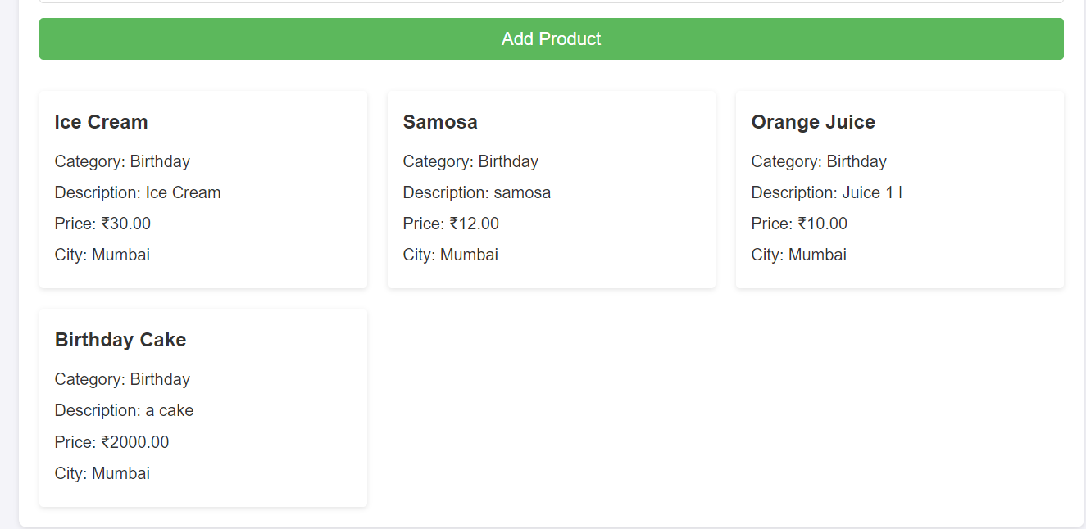

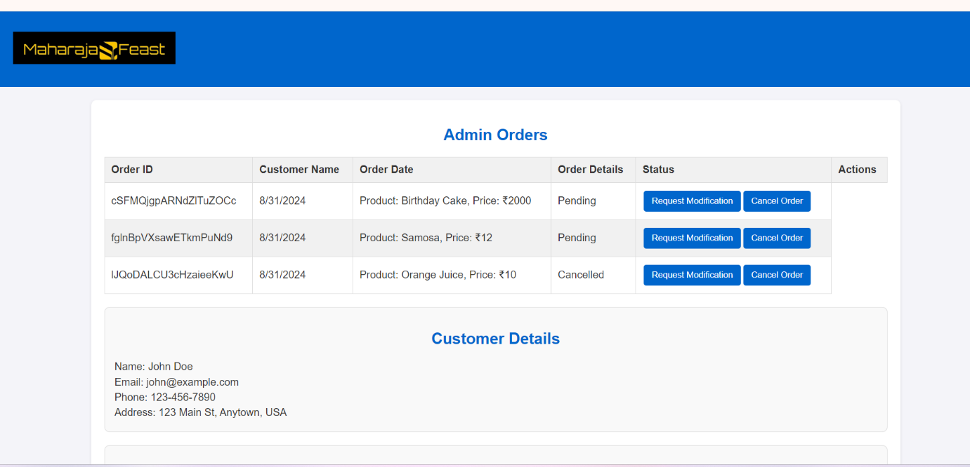
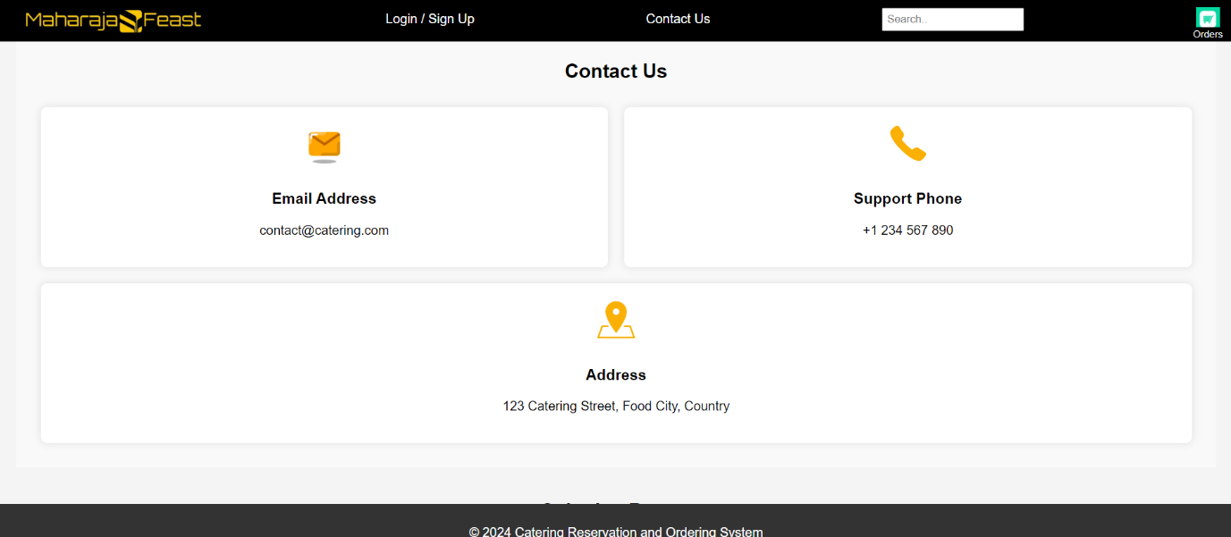

User Modules :
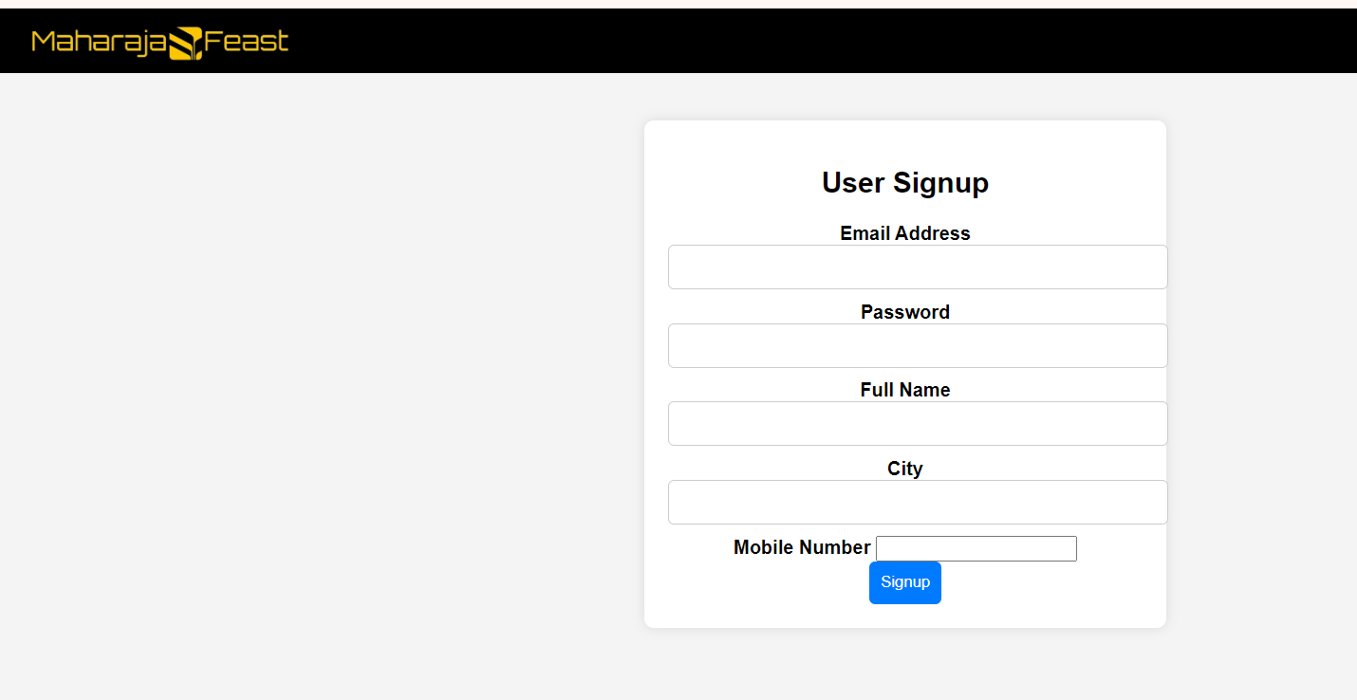

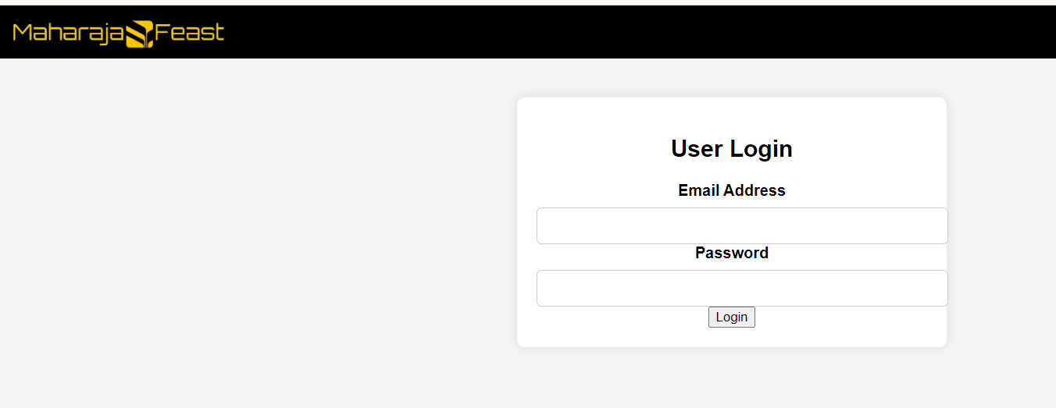

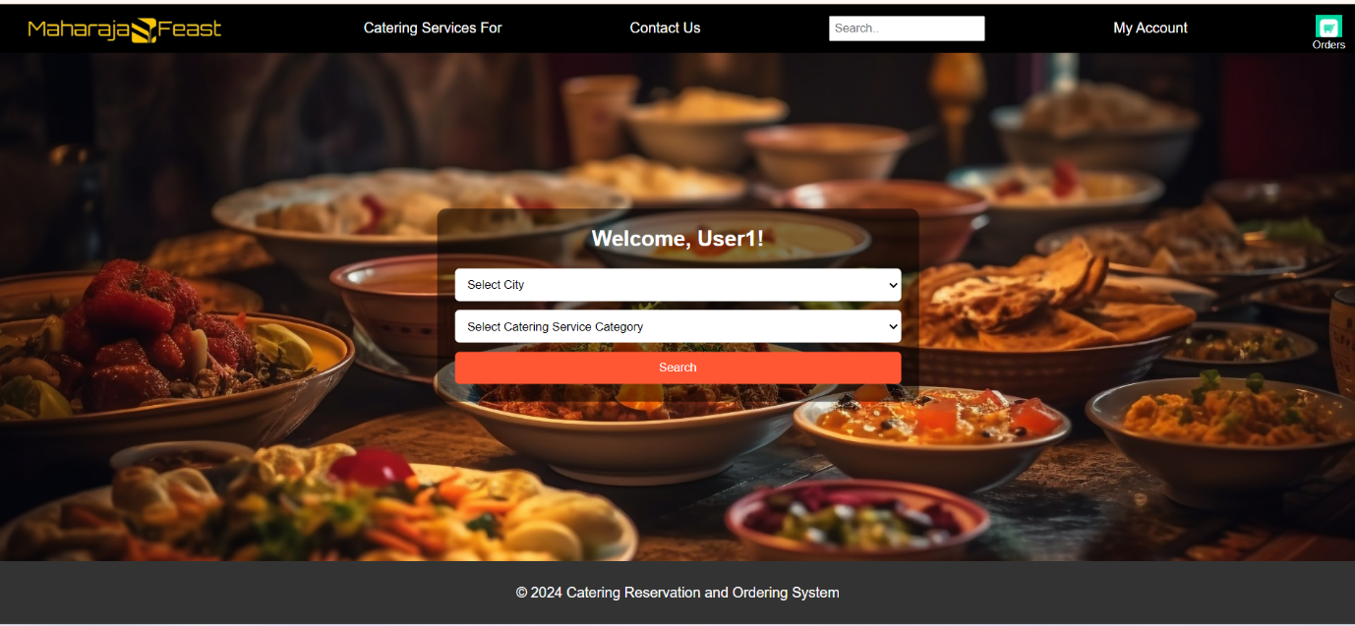
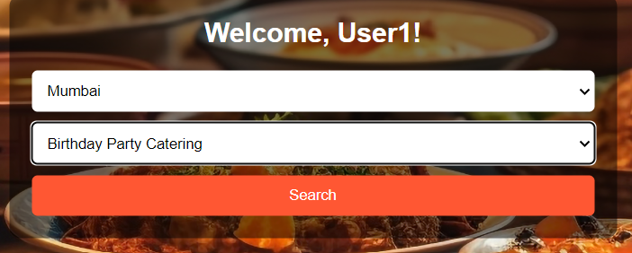

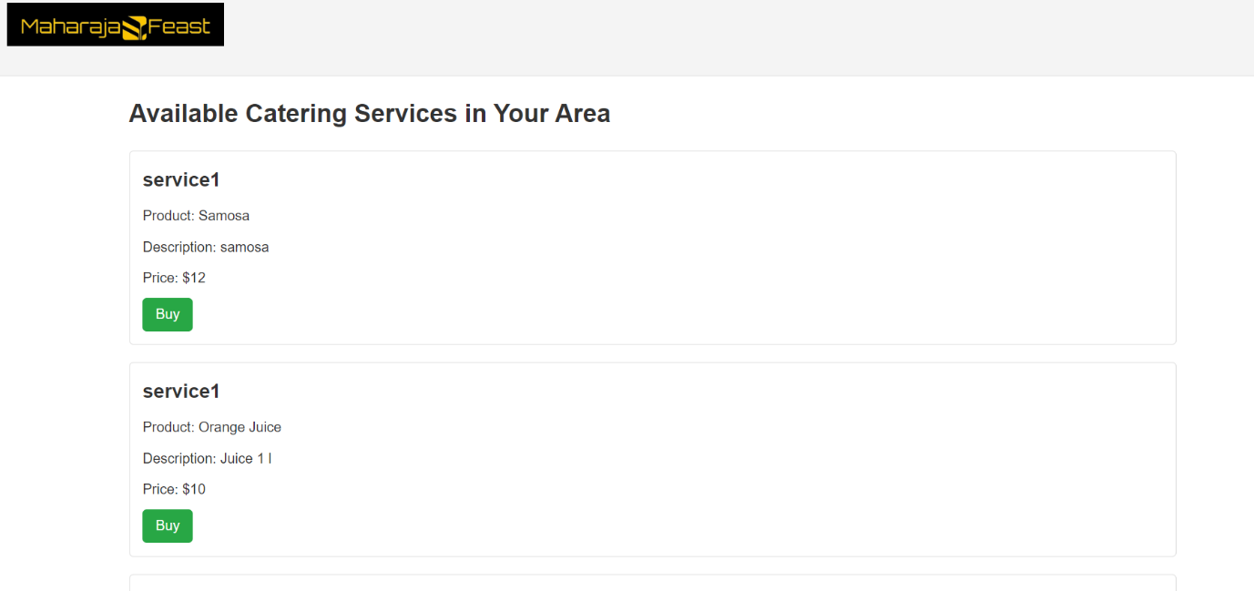

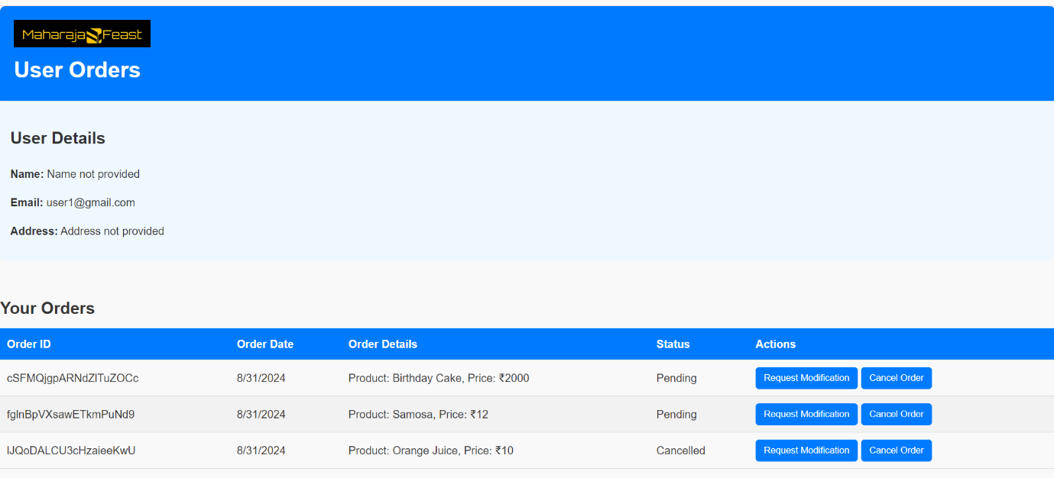

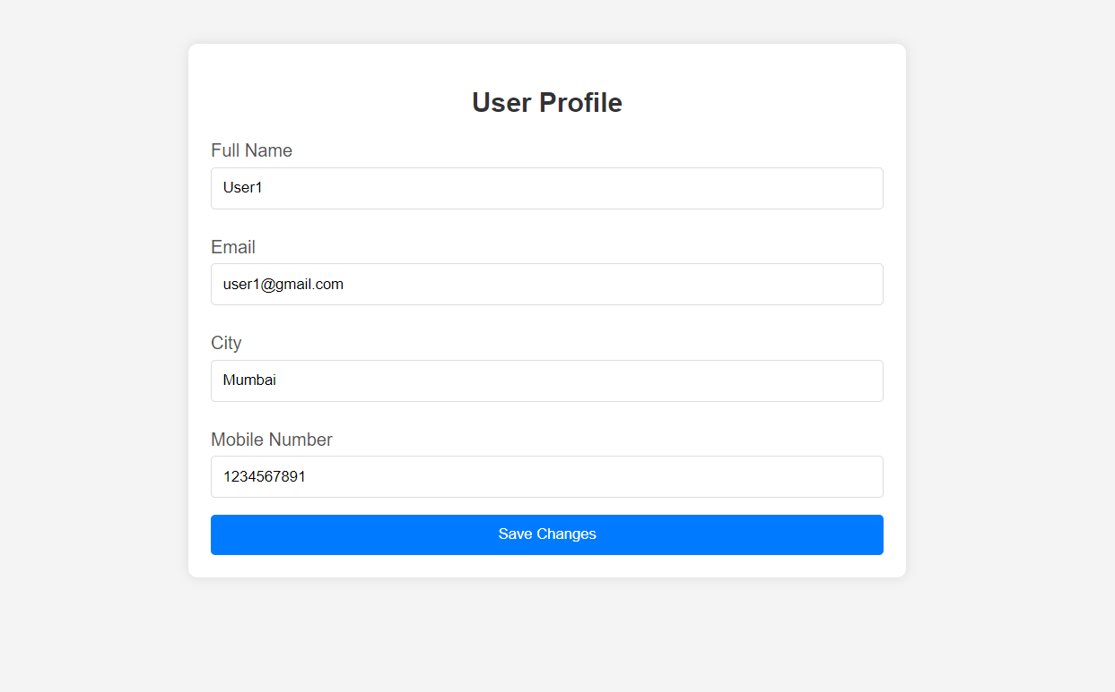

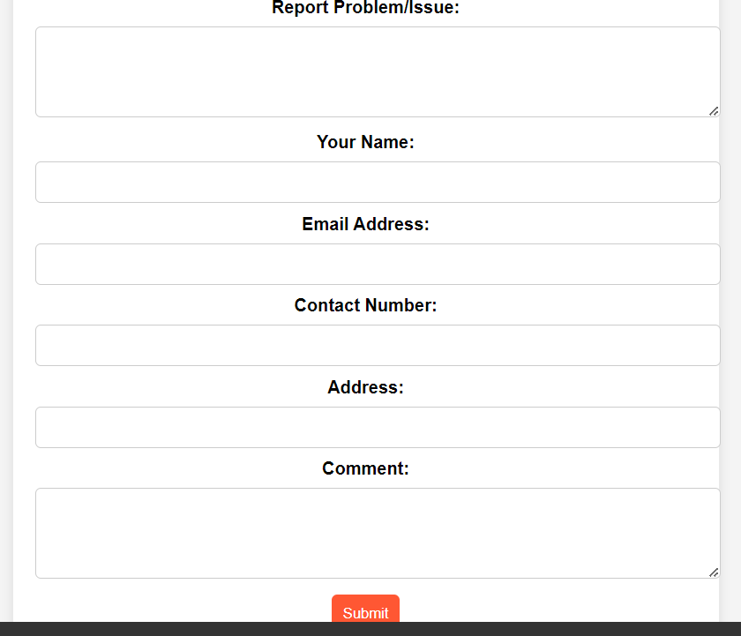

Firebase Backend :
